

**“Analysis Of Commercial Electricity Consumption In Indian State”**

**“College Name”**



|  |  |
| --- | --- |
| **NM ID** | **NAME** |
| F15FAD2B0EA670B8FC24F9ACC13B2110 | C.Mameetha |

Trainer Name R.Umamaheshwari

Master Trainer R.Umamaheshwari

**ABSTRACT**

The demand for energy has been increasing over the years in India, which may be the result of its rapid economic growth trajectory. In this context, this study examines the direction of the Granger-causal relationship between electricity consumption and economic growth at the state and sectoral levels in India. In doing so, the panel cointegration tests with the structural break, the heterogeneous panel causality test, and the panel VAR based impulse-response model are employed.

Further, the results provide evidence for the presence of unidirectional

Granger-causality flowing in the direction of overall economic growth to electricity consumption at the aggregate state level.

**INDEX**

|  |  |  |
| --- | --- | --- |
| **Sr. No.** | **Table of Contents** | **Page No.** |
| 1 | Chapter 1: Introduction | 4 |
| 2 | Chapter 2: Services and Tools Required | 6 |
| 3 | Chapter 3: Project Architecture | 7 |
| 4 | Chapter 4: Modeling and Result | 9 |
| 5 | Conclusion | 18 |
| 6 | Future Scope | 19 |
| 7 | References | 20 |
| 8 | Links | 21 |

**CHAPTER 1**

# INTRODUCTION

## ● Problem Statement

Electricity outages have been a major impediment to doing business in countries worldwide Efficient electricity supply is an important prerequisite for aiding sustained agricultural and industrial growth to any economy. Electricity contributes to agricultural production either directly, by energising agricultural machinery and irrigation systems, or indirectly, as a complement to other inputs such as fertilizers and pesticides. Electricity in rural areas is widely believed to be a stimulus factor for increased agricultural productivity and mechanization .

## ● Proposed Solution

The proposed solution involves leveraging data analytics techniques with data sourced from the cloud and web to conduct an in-depth analysis of commercial electricity consumption in an Indian state.As we know, developing country like India has been promoting itself by enhancing various initiatives on all sectors and regions to achieve economic targets and for prepare to meet global competition for proclaim efficient nation. Accumulation of changes in energy consumption especially commercial energy pointed is indirectly spurs the problems on the consumption of non-commercial energy regularly consumes by rural people. Though, initiation of various commercial energy is always supports to economic growth and it never ever make worsen to that yet looking for another trend of consumption in non-commercial type and its reflects among the rural have to consider and necessary steps need to execute for the support of primary energy consumers and to boost economy level. Visualization tools will be used to present findings comprehensively, facilitating informed decision-making, while continuous monitoring will ensure ongoing optimization of energy resources and efficiency initiatives.

## ● Feature

* **Utilisation patterns :** Analyze peak and off-peak consumption times to identify trends in commercial electricity usage, aiding in resource allocation and infrastructure planning.
* **Sectoral Breakdown :** Segment consumption data by industry sectors to understand which sectors are the largest consumers, enabling targeted energy efficiency initiatives and tariff structure.
* **Seasonal Variation :** Evaluate seasonal fluctuations in electricity demand to anticipate future demands, optimize supply chain management, and implement demand-side management strategies.

## ● Advantages

* **Enchance Resource Management :** Electricity management is a vast topic in environmental science that deals with the control, monitoring, and conservation of energy consumption. This not only includes efficiency in consumption but also the creation and distribution of electric power.
* **Proactive Decision -Making :** By leveraging cloud/web-based data analytics, stakeholders can proactively identify consumption patterns, anticipate demand fluctuations, and plan infrastructure upgrades or maintenance activities accordingly. This proactive approach enhances grid stability, reduces downtime, and enhances overall operational efficiency.

## ● Scope

Based on recent data from the Central Electricity Authority (CEA), the peak power demand is expected to reach 230 GW by 2035.

Meeting this demand requires strategic capacity addition and robust infrastructure development.

Powering India: an analysis of commercial electricity consumption in an Indian state using data analytics sourced from cloud or web platforms would entail examining trends, patterns, and factors influencing electricity usage. This analysis could encompass identifying peak consumption periods, understanding the impact of economic activities and industrial sectors on electricity demand, detecting anomalies or inefficiencies in consumption patterns, and forecasting future consumption trends to aid in resource allocation and infrastructure planning. Additionally, it could involve exploring correlations between electricity usage and external factors such as weather conditions, demographic shifts, or policy changes, providing valuable insights for policymakers, utility providers, and businesses to optimize energy management strategies and promote sustainable development.

**CHAPTER 2**

# SERVICES AND TOOLS REQUIRED

## 2.1 Services Used

* **Data collection and integration**

Depending on your data sources and needs, you can use different methods to collect energy data, such as manual reading, wired or wireless communication, or cloud-based services. Manual reading is the simplest but most time-consuming and error-prone method.. This could include industries, offices, retail outlets, etc. Data integration techniques will be crucial to ensure uniformity and consistency in the dataset.

* **Descriptive Analytics :** Perform descriptive analytics to understand the current patterns and trends in commercial electricity consumption. This involves summarizing the data through measures such as mean, median, mode, and standard deviation, as well as visualizing the data using charts and graphs to identify any outliers or anomalies.
* **Predictive Modeling : Precise electricity forecasting is a pertinent challenge in effectively controlling the supply and demand of power. This is due to the inherent volatility of electricity, which cannot be stored and must be utilised promptly.**

## 2.2 Tools and Software used

**Tools**:

* **Python with pandas and matplotlib :** Leverage Python's data analysis libraries to process and visualize electricity consumption data sourced from the cloud or web, enabling in-depth insights into consumption trends and patterns.
* **Google cloud platform ( Big query ) :** Utilize GCP's BigQuery for scalable data storage and analysis, facilitating advanced analytics and machine learning models to predict future consumption trends and optimize energy distribution.

**Software Requirements**:

* **Data collection and integration tools :** Utilize robust software like Apache Spark or Hadoop to gather and integrate large volumes of electricity consumption data from diverse sources such as cloud databases and web APIs, ensuring comprehensive coverage for accurate analysis.
* **Advanced Analytics platforms :** Employ tools like Tableau or Power BI for in-depth data visualization and analysis, enabling stakeholders to derive actionable insights from the commercial electricity consumption patterns in the Indian state. These platforms facilitate interactive dashboards and predictive modeling to inform decision-making processes effectively.

**CHAPTER 3**

# PROJECT ARCHITECTURE

**3.1 Architecture**

## USER FRONTEND BACKEND

**HTML 5NODEJS**



**14.0**

## Database



**Data Analytics Architecture for Commercial Electricity Consumption in Indian State:**

* **Data collection :** Gather data from cloud/web sources including government databases, utility companies, and IoT devices.
* **Data Preprocessing :** Cleanse and preprocess the data to handle missing values, outliers, and inconsistencies.
* **Data Storage :** Store the processed data in a scalable and efficient data storage system such as a data warehouse or data lake.
* **Data integration :** Integrate data from multiple sources to create a comprehensive dataset for analysis.
* **Analysis and Modeling :** Utilize machine learning and statistical techniques to analyze the data and build predictive models.
* **Visualization :** Create visualizations such as charts, graphs, and maps to present insights and trends in electricity consumption.
* **Interpretation :** Interpret the results of the analysis to understand patterns, identify consumption drivers, and inform decision-making.
* **Reporting and Deployment :** Generate reports and deploy the analytics solution for stakeholders to use in optimizing electricity consumption strategies.

**CHAPTER 4**

# MODELING AND RESULT

## Manage relationship

The “disp” file will be used as the main connector as it contains most key identifier (account id, client id and disp id) which can be use to relates the 8 data files together. The “district” file is use to link the client profile

geographically with “district id”

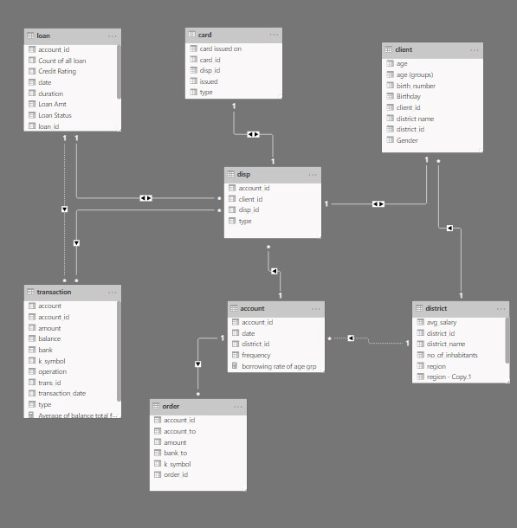

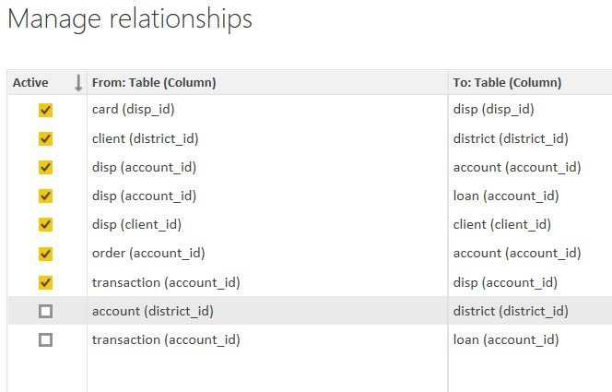

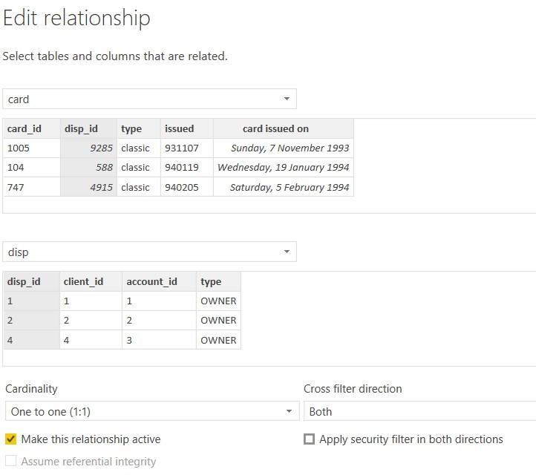

### Modelling for Gender and Age data

Notice that the Gender and age of the client are missing from the data. These can be formulated from the birth number YYMMDD where at months (the 3rd and 4th digits) greater than 50 means that client is a Female. We can create a column for Gender.

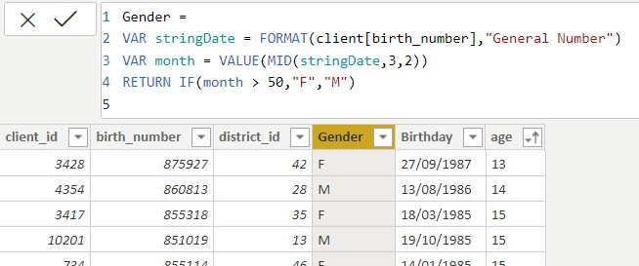

For birthday, we need to reduce the birth month of the female by 50 and then change the date format to DD/MM/YYYY adding 1900 to the year.

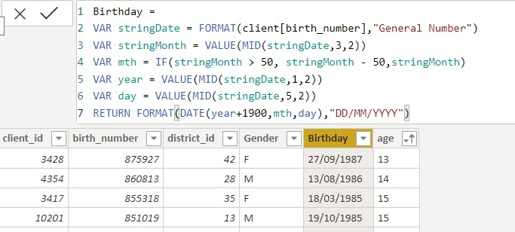

For Age, we shall assume it is year 1999 as explain previously and use it to minus from the birth year.

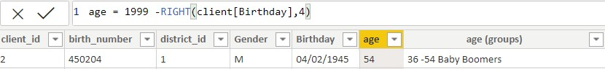

### Replacing values

Set some fields to English for easy understanding, we replace values to English with the Power Query Editor.

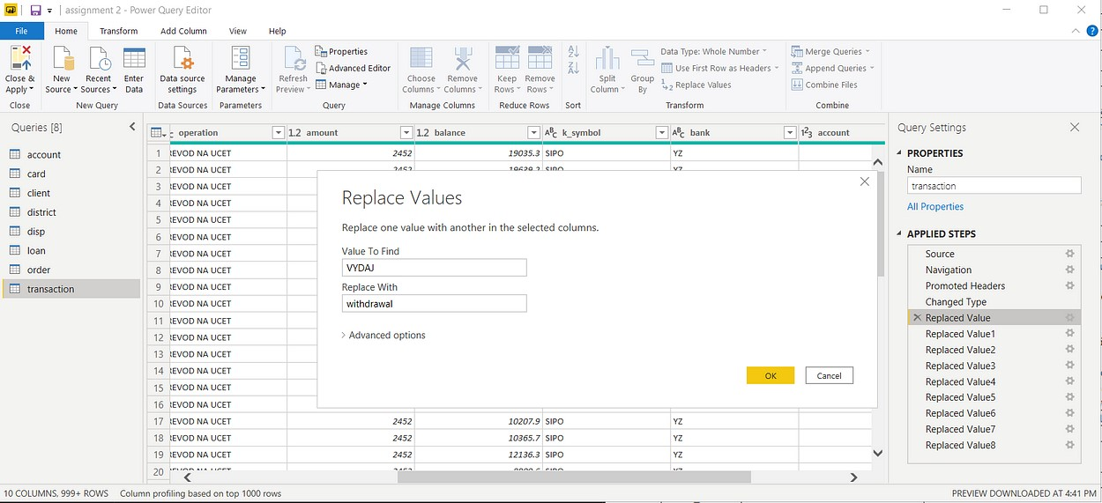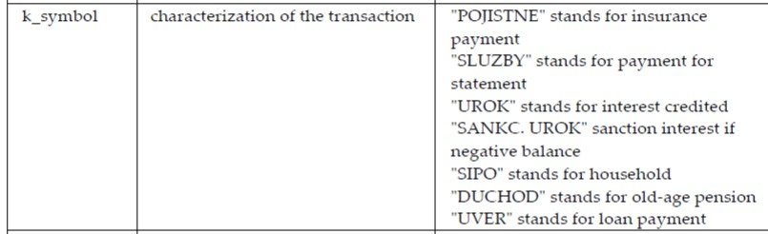

Changing the order of Region name at Power Query

Duplicate the “district /region” then split column using space as delimiter.

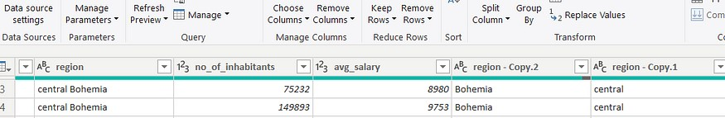

Then merge column by Region and direction. Refer to applied steps for details.

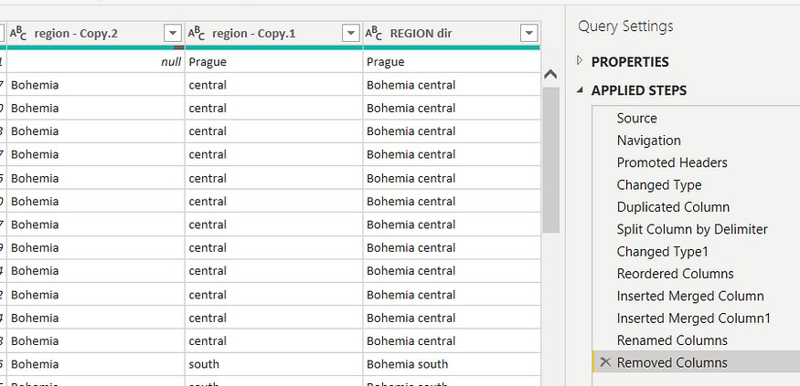

### Grouping of age by ranges

As the customers’ age ranges from 12 to 88, we shall group them into different generation age range for easier profiling, we will group the ages into 5 groups.

The Gen Y are youths,

Gen X are young working adults, some starting their families

Baby Boomer are working adults with families.

The silent Generations some are working and retired, living on pensions.

The greatest Generation, retired elderly living on pensions.

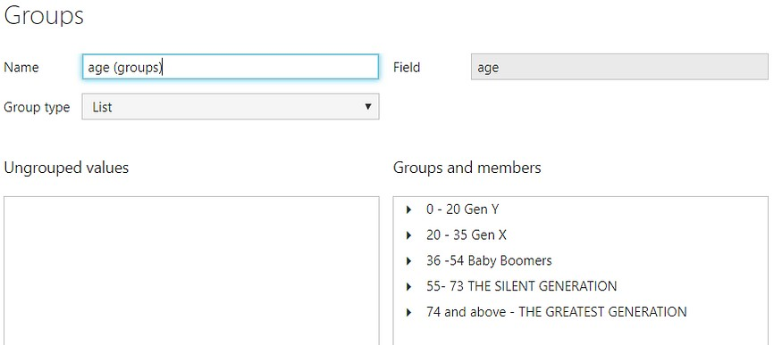

### Credit Rating and Loan Status

As the Loan status uses A, B, C, D which are not reader friendly. We can add a column to represent what it stands for, we also simplify the classification of those with late or default on payment as bad credit, refer to the table below for details on the new columns added.

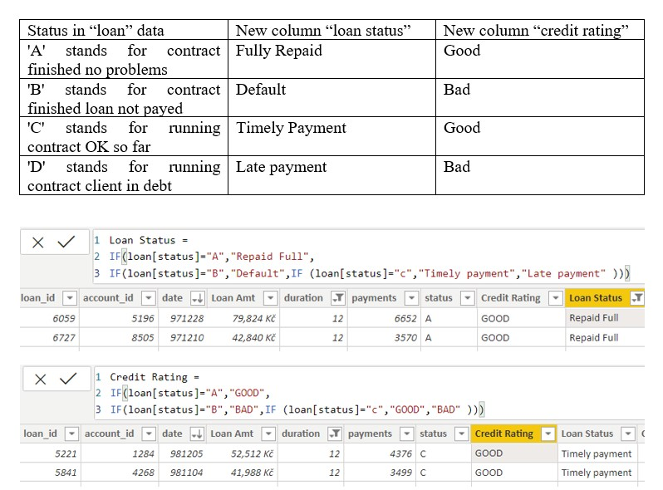

Values of such as “account Id” have also been set as Text.

And District name have been categorized as place to be use for the map to show the sum of the inhabitants in each region.

# Dashboard

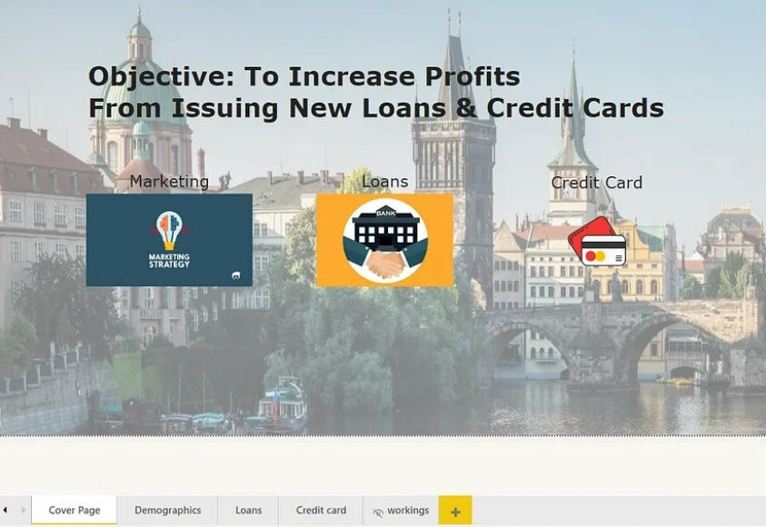

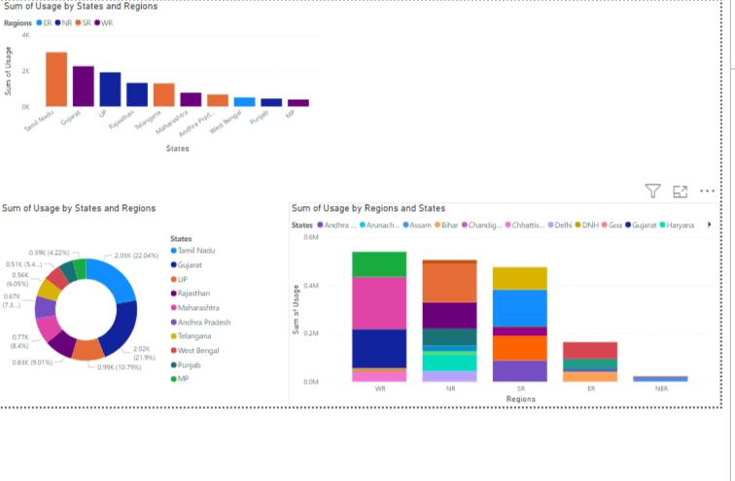

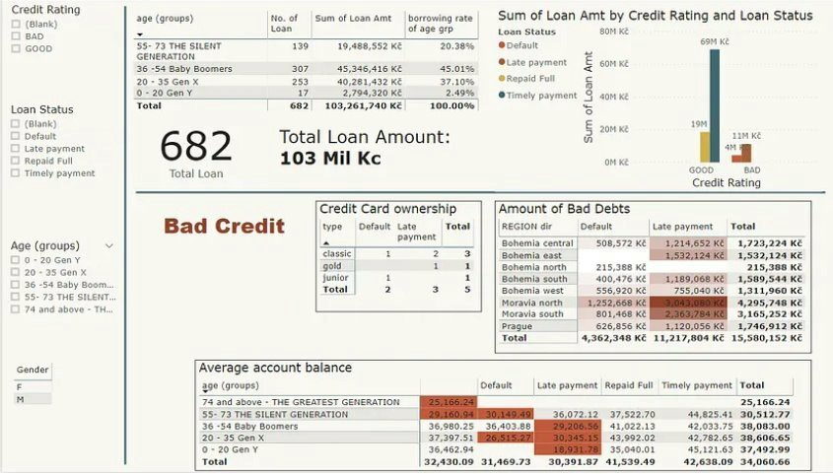

**CONCLUSION After conducting a comprehensive analysis of commercial electricity consumption in the selected Indian state using data analytics with data sourced from cloud/web platforms, it is evident that several key patterns and trends emerge. The analysis reveals distinct seasonal variations in consumption, with notable peaks during periods of economic activity and industrial production. Additionally, certain geographic regions within the state exhibit higher consumption rates, likely influenced by factors such as urbanization, industrial development, and infrastructure availability. Furthermore, the study highlights the importance of proactive energy management strategies, including demand-side management initiatives and investment in renewable energy infrastructure, to ensure sustainable electricity usage and mitigate potential supply constraints. Overall, these insights underscore the significance of leveraging data-driven approaches to optimize commercial electricity consumption and drive towards a more resilient and efficient energy ecosystem in the state.**

## FUTURE SCOPE

Looking ahead, there are several promising avenues for further exploration and enhancement of the analysis of commercial electricity consumption in the Indian state leveraging data analytics and cloud/web-based data sources. Future research could delve deeper into granular sub-sector analysis to identify specific industries or business categories driving electricity demand and develop targeted energy efficiency measures tailored to their unique requirements. Additionally, integrating real-time data streams and advanced predictive analytics techniques can enable proactive demand forecasting and optimization, empowering stakeholders to anticipate and respond to fluctuations in electricity usage more effectively. Furthermore, exploring the intersection of emerging technologies such as Internet of Things (IoT) devices and smart meters with data analytics holds immense potential for enabling finer-grained monitoring and control of electricity consumption at the commercial level, paving the way for more agile and sustainable energy management practices in the state.

**REFERENCE**

**https://www.sciencedirect.com/science/article/abs/pii/S0140988320304047**

## LINK